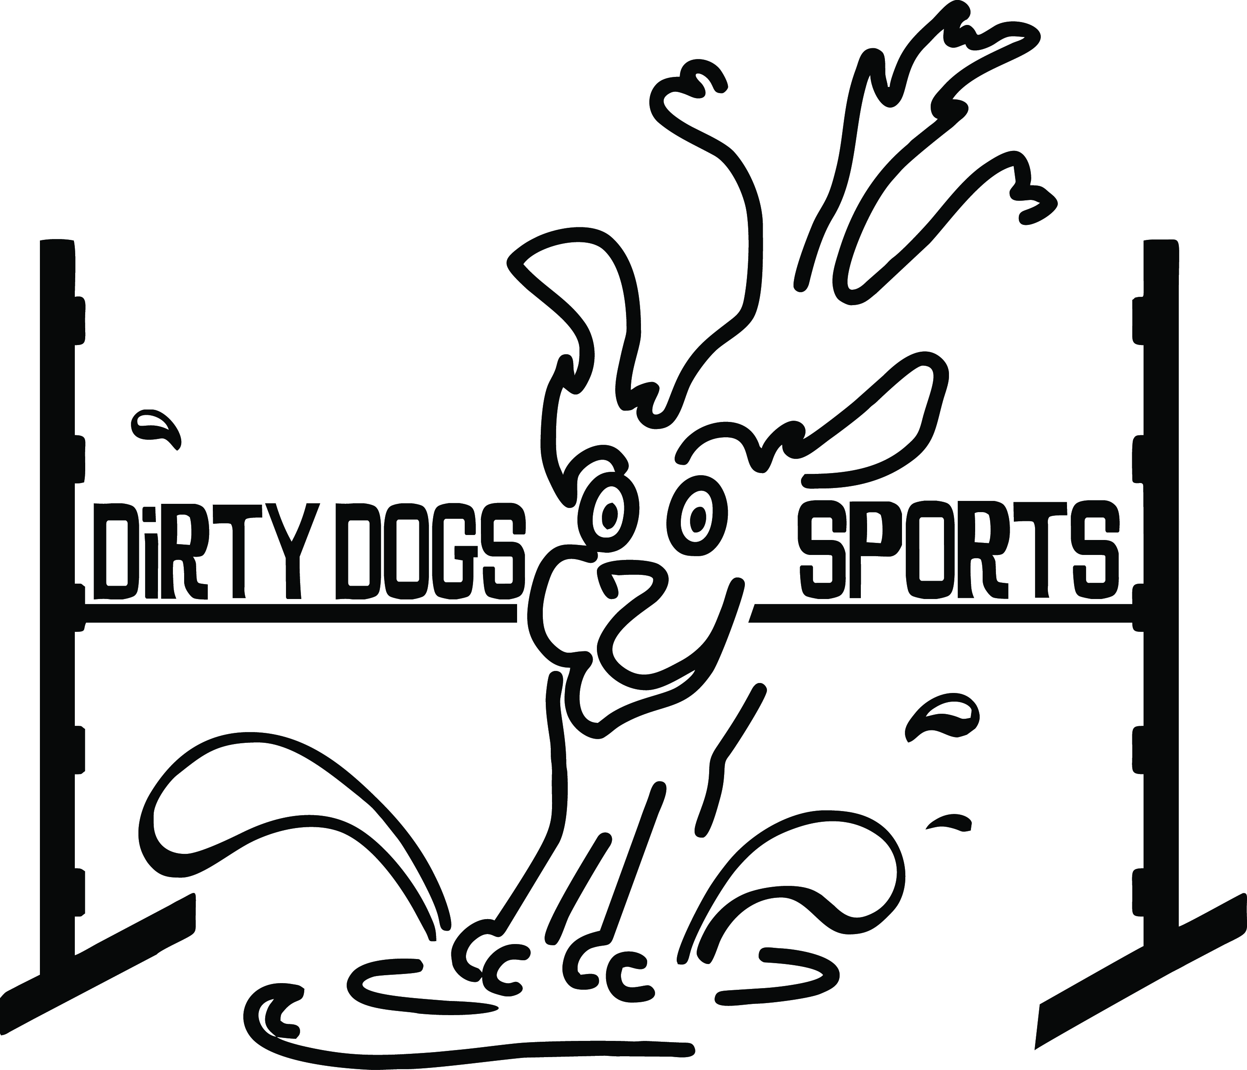
DIRTY DOGS SPORTS  Agility by the Lake  June 25-27, 2021  Milliron Arena  32069 Cutting Horse Lane  Polson, MT 59860  Judge:  Carol Scranton  Double run or Single Run  or Mixed Trial format:  Double run  Building and Ring Surface info:  Dirt/Sand  Contact Surface:  Rubber Matted  Crating Set up times:  8 am  Briefing at:  Friday: 9:30 am  Saturday 8:45 am  Sunday 8:45 am | Preliminary Class Order:  May change depending on weather, judges preference, time or number of entries  Friday  Class: Number of Rounds:  Barrelers 2  Touch n Go 2  Regular 2  Saturday  Class: Number of Rounds:  Regular 2  Chances 2  Weavers 2  Hoopers 2  Sunday  Class: Number of Rounds:  Regular 2  Jumpers 2  Tunnelers 2  First dog on the line at:  Friday 10:00am  Saturday 9:00 am  Sunday 9:00 am

Entries Open on:  When premium is posted  Entries Close on:  June 19 or when trial fills.  Crating available:  Crating on dirt  Entry Limits:  500 runs per day  Move ups:  Move ups accepted day to day  Day of show Entries:  Day of show entries accepted until trial fills  Refunds:  Dogs that are injured or bitches in heat are due a full refund before closing date. After closing, entry fee less $4.00 per run will be refunded on request. | Show Committee  Trial Chairs:  Karen McLeod 406-546-4300  Jan Thingelstad 406-253-5581  dirtydogssports@gmail.com  Secretary: Karen McLeod  Day of Secretary: Susan Randall  Chief Ring Steward: Spring McKee  Chief Course Builder: Timothy Anderson  Confirmations:  Confirmations will be mailed out no later than June 23, 2021  Food info:  Food will be explained in your trial info  Volunteer info:  No trial can run efficiently without help. There will be a sign up board listing jobs for each class. Experience is not necessary, we are happy to teach anyone willing to learn!  Awards and Ribbons:  1st-3th Ribbons in each class (pass/fail only in chances)  Purple Qualifying Ribbons  NATCH ribbons and bars. Please let us know if you are close so we can celebrate with you!  There will be gift bags for the first 30 entrants.  Equipment info:  All NADAC Spec equipment
Jump Height Info:
MEASURING
Measurement forms may be obtained at:
https://www.nadac.com/WPsite/wp-content/uploads/2019/06/HeightCardForm.pdf
Dogs which require measuring:
Dogs in the Proficient Category, Novice, Open or Elite jumping 4”, 8”, 12” or 16”

Dogs which do not need to be measured:
Dogs jumping 16” in the Veteran or Junior Handler Division
Dogs jumping 20”
Dogs in the Skilled Category
Dogs with a permanent height card
Dogs listed on the Height Exemption List
JUMP HEIGHTS
There are four Standard Division-Proficient jump heights: 8”, 12”, 16”, and 20”.
There are four Standard Division-Skilled jump heights: 4”, 8”, 12”, and 16”.
There are four jump heights for the Veterans and Junior Handler divisions: 4”, 8”, 12”, and 16”.
Please see the NADAC Rulebook for the full jump height table

Brief Summary of Rules:
Please refer to www.nadac.com for a full explanation of all NADAC rules and up to date information.

- Please note that NADAC trials should provide a safe and fun environment for both exhibitors and their dogs.
- Aggressive dogs will not be tolerated and will be excused from the trial.
- The show committee has the right to refuse any entry. Anyone not currently in good standing with NADAC will not be allowed to enter this trial.
- Exhibitors, through submission of entry, acknowledge that they are knowledgeable of NADAC rules and regulations, and agree to abide by all rules in effect at the time of this trial.
- No entry fee will be refunded if the trial cannot open or be completed by reasons of riots, civil disturbances, fire, acts of God, public emergency, an act of a public enemy, or any other cause beyond the control of the organizing committee.
- Checks not honored by the bank do not constitute a valid entry fee. There will be a $25.00 service charge for bank returned checks.
- Dog must be registered and have a valid registration number before entries will be accepted. http://nadac.com/afrm/dogregfrm.asp A copy of the current Exhibitors Handbook may be downloaded free from the NADAC web site: www.nadac.com
- Bitches in heat, lame, or blind dogs are ineligible for entry, as is any dog with a deformity which may cause a judge to not be able to reasonably assess the dog’s ability to function and perform agility obstacles safely, and in a manner that is in the best interest, health and welfare of the dog.
- No food, clickers, or other aids or devices shall be permitted on the course or within 10 feet of the ring. Food or a small non-audible toy can be in a secure container (ziplock bag is acceptable) in your pocket during your run but it cannot be used during your run, nor can you indicate to the dog it is there. Only Intro and Novice handlers my bring a non-audible toy into the ring for training purposes. They cannot earn a Qualifying score and must declare to the judge they are training before they commence their run. Please read the Exhibitor’s Handbook for more information about toys and training in the ring.
- The sponsoring clubs will not be responsible for the loss or damage to any dog exhibited, or for the possessions of any exhibitor whether the result be accident or other cause. It is distinctly understood that every dog at this event is in the care and control of his owner or handler during the entire time the dog is on the show premises.

Agility By The Lake, June 25-27, 2021
Dirty Dogs Sports
32069 Cutting Horse Lane, Polson, MT
Send entries to: Dirty Dogs Sports 41897 Rolling Rd Ronan, MT 59864 or email to dirtydogssports@gmail.com
Make Checks Payable to: Dirty Dogs Sports or PayPal PayPal.Me/dirtydogssports
Owner |  |  |  |  |  | Dog
Name |  |  |  |  |  | Call Name
Address |  |  |  |  |  | NADAC Reg #
City/State/Zip |  |  |  |  |  | Date of Birth
Phone |  |  |  |  |  | Height at Withers
Email |  |  |  |  |  | Breed
Handler, If not owner |  |  |  |  |  | Emergency Contact Name/Phone
PLEASE INCLUDE A COPY OF YOUR DOG’S HEIGHT CARD IF YOU DO NOT HAVE ONE ON FILE.
CATEGORY: PROFICIENT SKILLED
DIVISION: STANDARD VET DOG VET HANDLER JUNIOR HANDLER
I WANT MY DOG TO JUMP: 4 8 12 16 20
 | Class | Level |  |  |  |  | Day
 |  | Intro | Novice | Open | Elite |  | Friday | Saturday | Sunday
 | Regular |  |  |  |  |  | Rd 1 Rd 2 | Rd 1 Rd 2 | Rd 1 Rd 2
 | Chances |  |  |  |  |  |  | Rd 1 Rd 2
 | Jumpers |  |  |  |  |  |  |  | Rd 1 Rd 2
 | Touch n Go |  |  |  |  |  | Rd 1 Rd 2
 | Tunnelers |  |  |  |  |  |  |  | Rd 1 Rd 2
 | Weavers |  |  |  |  |  |  | Rd 1 Rd 2
 | Barrelers |  |  |  |  |  | Rd 1 Rd 2
 | Hoopers |  |  |  |  |  |  | Rd 1 Rd 2
 | In consideration of the acceptance of this entry, I/we certify that I/we have knowledge of, and are familiar with, and agree to abide by, the Rules and Regulations of NADAC in effect at the time of this trial, and by any additional rules and regulations as approved by NADAC for this trial. I/we certify that the dog entered is not a hazard to persons or other dogs. I/we further agree to be bound by the “Agreement” printed on page 5 of this premium
Number of Total Runs Entered (all dogs): # ___________
□ 1- 7 Runs = $12 each = ___________
□ 8-12 Runs= $11 each =___________
□ 13 or more runs = $10 each = ___________
□ Junior Handler = $6 each = ___________
□ Day of Show (after closing) $12 each = ___________

TOTAL ENCLOSED =___________

Owner/Exhibitor: ____________________________________Date______________________
Parent or Legal Guardian of Junior Handler__________________________________________

AGREEMENT
The person who signs this agreement represents that he/she is authorized to enter into this agreement on
behalf of both exhibitor and the owner of entered dog. In consideration of acceptance of this entry:
1.1. As used here "NADAC" means the North American Dog Agility Council, LLC. its members officers, directors, employees, show chairs, show committees and agents.
1.2. Exhibitor/owner agree to abide by the rules and regulations of NADAC and any other rules and
regulations appearing in the premium for this event.
1.3. Exhibitor/owner certify that the entered dog is not a hazard to persons, dogs or property and that
The entered dog's rabies vaccination is current in accordance with the requirement of the state in which the dog resides.
1.4. Exhibitor/owner acknowledge all hazards presented by the event and the event premises,
including, but not limited to, the condition of the surface, restrooms, security measures or lack of,
electrical appliances, fittings, show rings, parking areas and the presence of unfamiliar animals and
people; exhibitor and owner assume the risk of any harm arising from these.
1.5. Exhibitor/owner releases NADAC (including its respective officers, directors, employees, and
members), Dirty Dogs Sports, LLC (including its officers, directors, members, and event organizing
committee), and Milliron Arena (including its officers, agents, and employees) and will
defend them and hold them harmless from all present and future loss, injury, damage, claims, demands
and liabilities involving the entered dog, the event or event premises. Without limiting the generality of the
foregoing hold harmless provisions, exhibitor/owner hereby specifically assumes sole responsibility for
and agrees to indemnify and save the aforementioned parties harmless from any and all loss and
expenses (including legal fees) by reason of the liability imposed by law upon any of the aforementioned
parties for damages because of bodily injuries, including death, at any time in consequence of my (our)
participation in this event, howsoever such injury or death may be caused and whether or not the same
may have been caused or may have been alleged to have been caused by negligence of the
aforementioned parties or any of their employees or agents or any other persons.

ASSUMPTION OF THE RISK AND WAIVER OF LIABILITY RELATING TO CORONAVIRUS/COVID-19
This Form must be completely filled out by each attendee and participant, including children.
The novel Coronavirus (“COVID-19") has been declared a worldwide pandemic by the World Health Organization. COVID-19 is extremely contagious and is believed to spread mainly from person-to-person contact. As a result, federal, state, and local governments and federal and state health agencies have recommended social distancing and have, in many locations, prohibited or limited the congregation of groups of people. The North American Dog Agility Council, LLC, (hereinafter “NADAC”), has put in place preventative measures to reduce the spread of COVID-19; however, NADAC, cannot guarantee that you will not become infected with COVID-19. Further, attending and/or participating in a NADAC trial could increase your risk of contracting COVID-19.
By signing this document, I acknowledge the contagious nature of COVID-19 and voluntarily assume the risk that I may be exposed to or infected by COVID-19 as a result of attending and/or participating in a NADAC trial and that such exposure or infection may result in personal injury, illness, permanent disability, and death. I understand that the risk of becoming exposed to or infected by COVID-19 at a NADAC trial may result from the actions or inactions of myself or others. I voluntarily agree to assume all of the foregoing risks and accept sole responsibility for my decision to attend and/or participate in a NADAC trial, and any personal injury, disability, illness, death, damage, loss, claim, liability, or expense of any kind, that I may experience or incur in connection with my participation in a NADAC trial.
I hereby release, covenant not to sue, discharge, and hold harmless NADAC, its directors, officers, employees, agents, representatives, volunteers, members, successors, and assigns, local trial hosts, judges, and participants from any and all liabilities, claims, actions, damages, costs or expenses of any kind arising out of or relating to my attendance and/or participation in a NADAC trial. I
understand and agree that this Assumption of Risk and Waiver of Liability Relating to Coronavirus/COVID19 covers any claims based on the action or inactions of myself, NADAC, its directors, officers, employees, agents, representatives, volunteers, members, successors, and assigns, local trial hosts, judges, and participants, regardless of whether a COVID-19 infection occurs before, during, or after participation in any NADAC trial.
Dated: ______________ __________________________________________
Signature
Minor Child Name: _________________ __________________________________________
(if applicable) Signature Parent/Guardian of Minor Child
*If more than one child, a separate from must be completed for each child.
Accepted by Local Trial Host: __________________________________________
Signature Local Trial Host Representative
Accepted by NADAC, LLC upon execution.

Lodging Info and Directions:
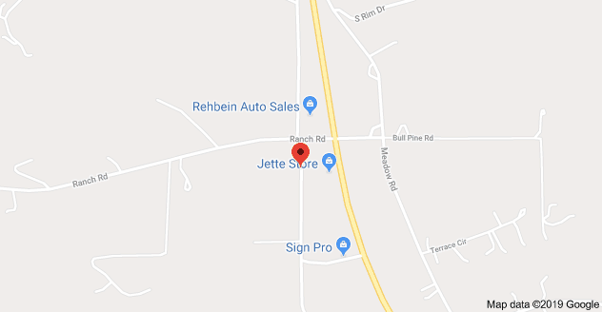
From Kalispell or north:
Follow Hwy 93 S. 5 miles before Polson turn right on Ranch Rd before the Jette Lake store, then right onto Cutting Horse Lane. Destination will be on the right.

From Missoula or south:
Follow Hwy 93 N to Polson, cross the bridge and proceed like you are going to Kalispell. Turn left onto Ranch Rd, then left onto Cutting Horse Lane. Destination will be on the right.
Hotels/Motels and camping:
Red Lion Inn: 209 Ridgewater Dr. 406-872-2200.
Ask for Dog Agility rate.
We have a block of rooms reserved until 2 weeks before the trial.
Rooms are $150.00. No pet fee.

Kwataqnuk Resort: 49708 US Hwy 93, 406-883-3636

Dry camping allowed at the Milliron Arena. No electrical hookups available. $10 per night.

